Date of request:

Name of School: |  |  |  |  |  | 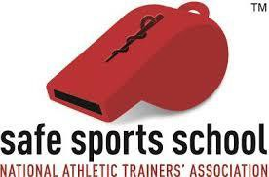
School Address:
City/State/Zip:
Athletic Trainer Submitting Request
AT Phone # |  |  |  | E-mail address
* NATA Member # |  |  |  | BOC #
* State License # |  |  |  | * NPI #
* NATA Membership, State License and National Provider Identifier numbers are required of all applicants.

 | Yes | No
Is the Athletic Trainer named above in good standing with the NATA?
Is the high school currently enrolled in the KSI NATA A.T.L.A.S. Program?
Is this a first-time application for the Safe Sports School Award?
Please indicate whether this application meets the criteria for 1st or 2nd team?

To complete this request for funding, please attach the following documents and submit to LaJoy Paige, SEATA SSATC Chair (ssatc@seata.org) by January 1st:
- A PDF copy of your completed NATA Safe Sports School Award Application, in its entirety, and
- Completed Grant Request Form (this document).

Grant Requests will be accepted from August 1st through January 1st of the awarding year. Requests may be accepted after this date based on funding availability.

NOTES:
- All District IX Grant funds will be disbursed directly to the NATA.
- Schools applying for a District IX Safe Sports School Award Grant SHOULD NOT submit their online application to the NATA prior to being notified of awarding of grant funds. Refer to the Grant Procedures information or contact Ciara Taylor, ciarataylor10@gmail.com with any questions.

