GUIDELINES FOR PROPOSAL SUBMISSION

45th Annual SEATA Clinical Symposium &
Members’ Meeting, Atlanta, GA
March 5-7, 2020

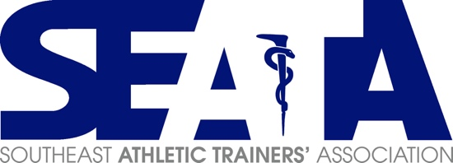

Proposals are currently being accepted for the 45th Annual SEATA Clinical Symposium & Members’ Meeting for:
- Feature Presentations
- Special Topics
- Workshops

All session proposals should be submitted at the following link: SEATA CSMM Session Proposal. All proposals are due by October 1, 2019.

General Guidelines:
- All presentations must avoid any affiliation with a commercial product or service.
- Speakers must be available for scheduling on any of the 3 days of programming.
- Proposal selection is contingent upon approval by the SEATA Research and Education Committee.
- Topics will be selected based on the organization of the program, quality of content and speakers, and significance of the material to the SEATA membership.
- Speakers must have an NPI numbers. To register for an NPI number, go to the following link for https://nppes.cms.hhs.gov/ - /. Detailed instructions for NPI number registration can be found here.
- Proposal Submissions must include the following elements:
  - Domains of Athletic Training
  - Education Level of the Presentation
  - Abstract (100 words or less)
  - Learning Objectives - Provide a minimum of 3 (i.e., "Attendees will be able to..."). Learning objectives should be written based on Bloom's taxonomy.
  - Purpose, knowledge, competency or performance gap addressed by the session
  - 3-5 references

Feature Presentation Specific Information:
- Feature Presentations are in-depth presentations on one topic relevant to the interest of the membership and should be organized to fall within the domains of practice for athletic training.
- Feature presentations are 1-1.5 hours in length with 1-3 speakers.
- Attendance is determined by room capacity.

Special Topic Specific Information:
- Special Topics are typically a lecture presentation and possible interactive discussions and must fall within the domains of practice for athletic training.
  - Special Topics do not provide room for participatory hands-on activities and do not include demonstrations, however, videos may be imbedded in the presentation and are encouraged if necessary to illustrate a technique or procedure.
- Special Topics are 1 hours in length with 1 speaker

Workshop Specific Information:

- Workshops are 1-1.5 hours in length with up to 2 speakers and should include a hands-on component to the session and must fall within the domains of practice for athletic training.
- Attendance is determined by room capacity.
- Equipment Acquisition
- With the exception of treatment tables and AV equipment, the submitter is responsible for securing and coordinating delivery of any equipment necessary for the Workshop. If treatment tables or specific AV equipment is needed, the presenter is responsible for notifying the Research and Education Committee by January 15, 2020.
- Vendors providing equipment may be acknowledged during the workshop, however, it is important that the session remain non-commercial.

Deadline
- Proposals must be submitted no later than October 1, 2019.
- Incomplete (e.g., missing speaker CV) and/or late proposals will NOT be accepted.

Compensation Policy

